ibsen_photonics_spectrometer Documentation

11/8/16

Kevin Kim

Project Structure:

* luna_filter_and_graph
  + ibsen_photonics_spectrometer
    - k_baseline.py
    - matricies.py
    - plot_and_filter.py
  + csv_files
  + utilities
  + experiment_logs

csv_files

Where the raw data file that is outputted from the ibsen spectrometer go.

FORMAT

|  |  |  |  |  |  |  |  |  |  |
| --- | --- | --- | --- | --- | --- | --- | --- | --- | --- |
|  | 0 | 1 | 2 | 3 | 4 | 5 | … | 2046 | 2047 |
| 171146580 |  |  |  |  |  |  |  |  |  |
| 171146841 |  |  |  |  |  |  |  |  |  |
| 171157100 |  |  |  |  |  |  |  |  |  |
| 171147620 |  |  |  |  |  |  |  |  |  |
| … |  |  |  |  |  |  |  |  |  |
| 171147849 |  |  |  |  |  |  |  |  |  |
| 171148012 |  |  |  |  |  |  |  |  |  |

Red = Pixel Number/Wavelength

* There is a total of 2048 pixel numbers

Blue = Quarter Second units.

Each wavelength the spectrometer reads corresponds with a specific pixel number.

For our case, we are interested in the following pixels.

1. Flu = 905
2. Joe = 956
3. TMR = 1000
4. CXR = 1037
5. WEN = 1167 (Standard)

|  |  |  |  |  |  |  |  |  |  |
| --- | --- | --- | --- | --- | --- | --- | --- | --- | --- |
|  | 0 | … | 905 | … | 999 | 1000 | 1001 | … | 2047 |
| 171146580 |  |  |  |  |  |  |  |  |  |
| 171146841 |  |  |  |  |  |  |  |  |  |
| 171157100 |  |  |  |  |  |  |  |  |  |
| 171147620 |  |  |  |  |  |  |  |  |  |
| … |  |  |  |  |  |  |  |  |  |
| 171147849 |  |  |  |  |  |  |  |  |  |
| 171148012 |  |  |  |  |  |  |  |  |  |

ibsen_photonics_spectrometer

Plot Correction Steps (proper_main(file_dir))

1. Load File
2. Time Averaging/K_filter/Get_5_Dyes
3. Matrix Correction
4. Baseline Subtraction
5. Plot

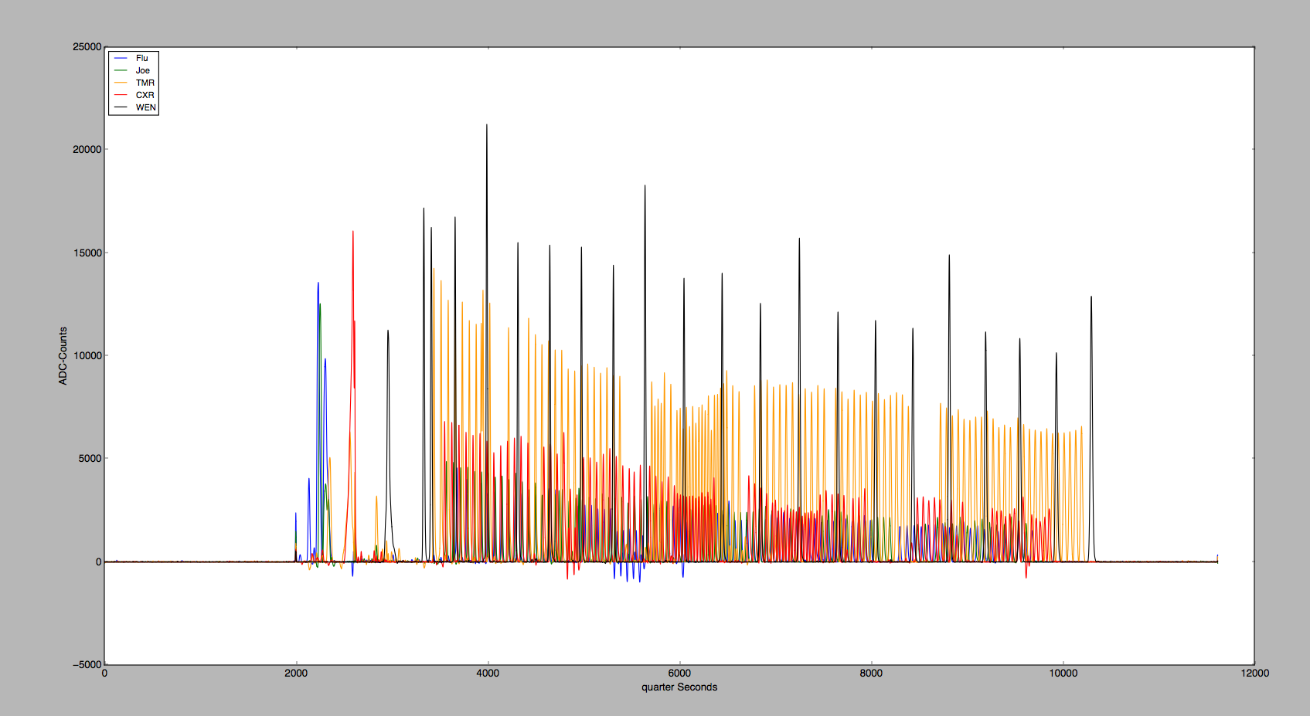

k_baseline.py

Python file that contains the Classes need to implement the K_baseline subtraction.

matricies.py

Python file that contains all the different calculated matrices used in the

matrix_correction(list_list_dyes, matrix).

plot_and_filter.py

All the functions that are needed to load a csv file in, and get a plot of the data as the output.